**Guide to using the ABS QuickStats Website**

1. Go to the website below by copying and pasting the weblink into the internet browser.

<http://www.abs.gov.au/websitedbs/D3310114.nsf/Home/Census?OpenDocument&ref=topBar>

1. In the search bar indicated below, type in the name of your town.

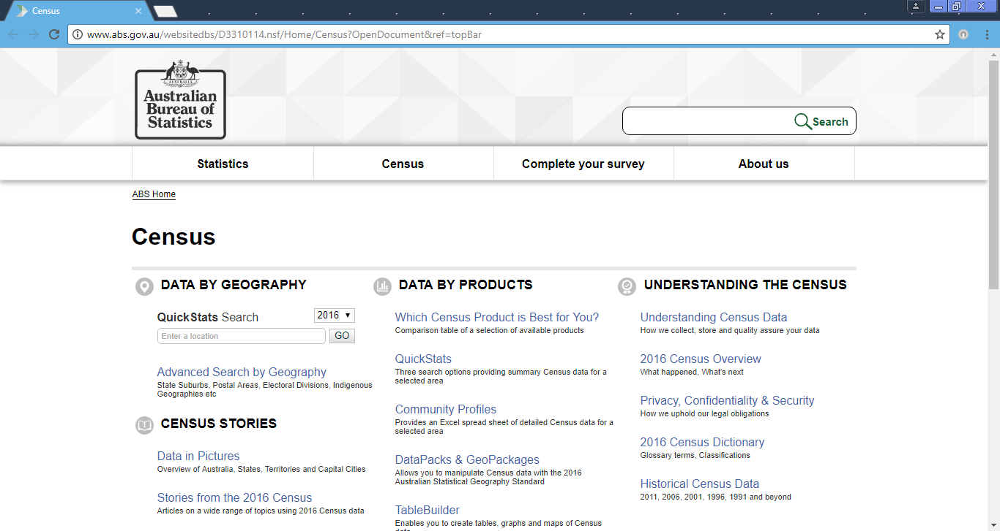

1. Select the option that has LGA at the end (Local Government Area) and click on GO!

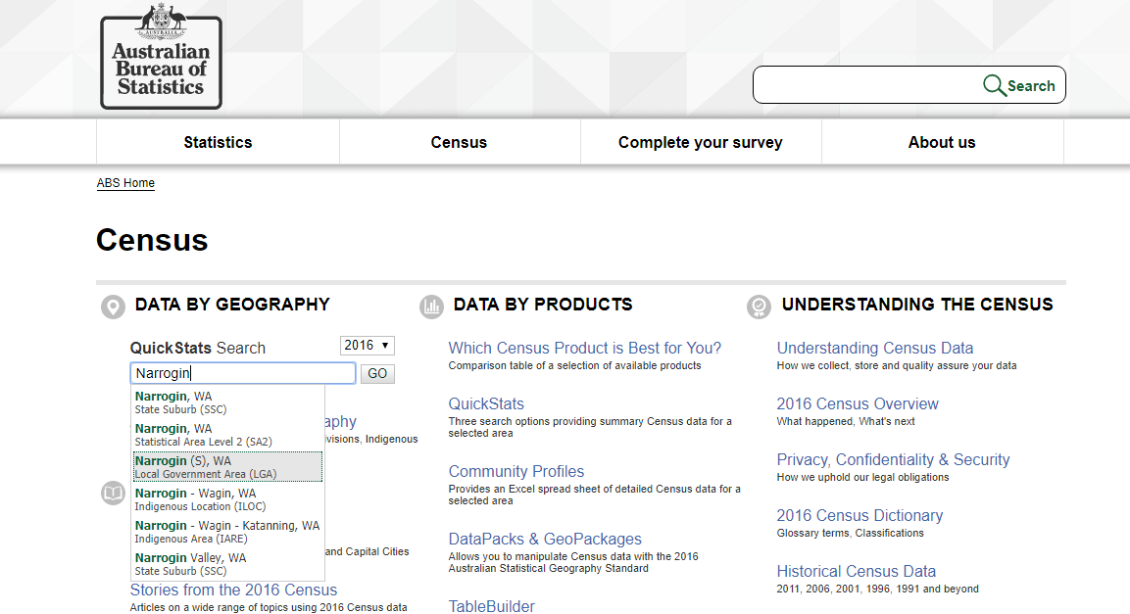

1. You will come to this page, scroll down the page and read the information and statistics. Find the data that you need to complete part A of your task.

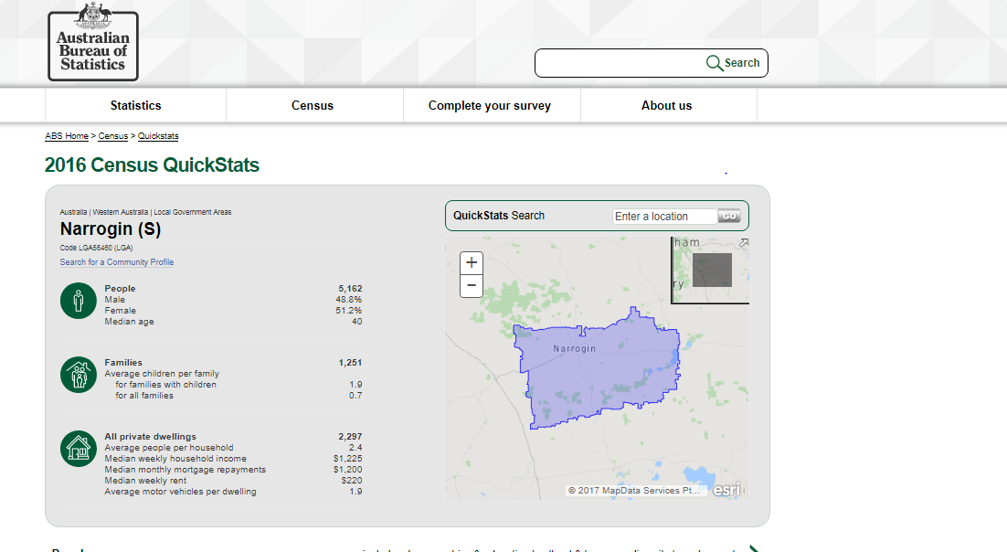

1. Scroll down the page to find the areas in the table that you need to fill in. You will find country of birth and ancestry the further you scroll down.

